
./
GENESIS - Learning Outcome & Mini-project Summary Report

Ver. Rel. No. | Release Date | Prepared. By | Reviewed By | To be Approved | Remarks/Revision Details
1 | 17/04/2021 | Arnav Kandpal(99003730)
Details

Contents
1 Contents 3
1 Mini-Project: Calculator 5
1.1 Modules 5
1.2 Features 5
1.3 Objectives & Requirement 5
1.3.3 High Level Requirements: 6
1.3.4 Low level Requirements: 6
1.4 Design 7
1.5 Test Plan 9
1.6 Implementation Summary 11
1.6.1 Git Link 11
1.6.2 Git Dashboard 11
1.6.3 Summary 11
1.7 Individual Contribution & Highlights 15
1.7.1 Summary 15
1.7.2 Challenges faced and how were they overcome 15
2. Mini-Project: Word Search Automation 16
2.1 Module 16
2.1.1 Topics 16
2.2 Objectives & Requirements 16
2.3 Design 16
2.4 Test Plan 17
2.4.1 High Level Tests 17
2.4.2 Low Level Tests 17
2.5 Implementation Summary 17
2.5.1 Git Link 17
2.5.2 Git Dashboard 18
2.5.3 Summary 18
2.6 Individual Contribution & Highlights 19
2.6.1 Summary 19
2.6.2 Challenges faced and how were they overcome 19
3 Mini-Project: Body Control Module 20
3.1 Module 20
3.1.1 Topics 20
3.2 Objectives & Requirement 20
3.3 Design 20
3.4 Test Plan 21
3.4.1 High Level Tests 21
3.4.2 Low Level Tests 21
3.5 Implementation Summary 21
3.5.1 Video Summary 22
3.5.2 Git Link 22
3.5.3 Git Dashboard 22
3.6 Individual Contribution & Highlights 23
3.6.1 Summary 23
3.6.2 Challenges faced and how were they overcome 23
4 Mini-Project: Body Control Module 23
4.1 Module 24
4.1.1 Topics 24
Power windows: Power window have a structure much like the hand powered or manual windows. The difference is the handle bars are replaced with motor and the motion is now actuated with the actuator or power circuit thus the name “Power Window”. 24
4.2 Objectives & Requirements 24
4.2.1 High Level requirements 24
4.2.2 Low Level Requirements 24
4.3 Design 25
4.4 Test Plan 27
4.4.1 High Level Requirements 27
4.4.2 Low Level Requirements 27
4.5 Implementation Summary 30
4.5.1 Video Summary 30
4.5.2 SharePoint Link 30
4.5.3 SharePoint Dashboard 30
4.5.4 Summary 31
4.6 Individual Contribution & Highlights 32
4.6.1 Summary 33
4.6.2 Challenges faced and how were they overcome 33
5 Canoe and CAPL Scripting (Launch Control ) 34
5.1 Module 34
5.1.1 Topic and Subtopics 34
5.2 Objectives & Requirements 34
5.3 Design 34
5.4 Test Plan 36
5.5 Implementation Summary 37
5.5.1 SharePoint Link 37
5.5.2 SharePoint Dashboard 37
5.6 Individual Contribution & Highlights 38
5.6.1 Summary 38
5.6.2 Challenges faced and how were they overcome 38
6 Intermediate C++ (Calculator)[Team/Individual] 38
6.1 Module 38
6.1.1 Topic and Subtopics 38
6.2 Objectives & Requirements 38
6.3 Design 38
6.4 Test Plan 39
6.5 Implementation Summary 39
6.5.1 Git Link 39
6.5.2 Git Dashboard 39
6.5.3 Summary 40
6.6 Individual Contribution & Highlights 40
6.6.1 Challenges faced and how were they overcome 40

Figure 1: SWOT Analysis Calculator 6
Figure 2: Deployment Diagram Calculator 8
Figure 3: Activity Diagram Calculator 9
Figure 4: Dashboard Calculator 12
Figure 5: Git Inspector Calculator 13
Figure 6: Build Calculator 14
Figure 7: Code Quality Calculator 15
Figure 8: Unit Testing Calculator 16
Figure 9: Individual Contribution Calculator 17
Figure 10: Design Word Search 18
Figure 11: Dashboard Word search 20
Figure 12: Code Quality Word Search 20
Figure 13: Design BCM 22
Figure 14: Implementation BCM 24
Figure 15: Git Dashboard BCM 25
Figure 16: Design Power Window 27
Figure 17: Stateflow Power Window 28
Figure 18: Stateflow Power Window 2 28
Figure 19: Dashboard Power Window 33
Figure 20:MCDC Power Window 34
Figure 21: Design Launch Control 36
Figure 22: Control Panel Launch Control 38
Figure 23: Cluster Launch Control 38
Figure 24:Trace Launch Control 39
Figure 25:Dashboard Launch Control 39
Figure 26: Test Plan C++ 41
Figure 27: Dashboard C++ 42

Table 1: High Level Requirements 7
Table 2: Low Level Requirements Calculator 7
Table 3: High Level Test Plan Calculator 10
Table 4 : Low Level Test Plan Calculator 12
Table 5: High Level test Word search 19
Table 6: Low level Test Word search 19
Table 7:High Level Test BCM 23
Table 8: Low Level Test BCM 23
Table 9: High level test Power Window 29
Table 10: Low Level Tests Power Window 32
Table 11: Test Plan Launch Control 37

Mini-Project: Calculator

Modules
- Applied Software Development Life Cycle.
- C programming.

Features
- Distance Conversion.
- PIN security.
- Area Perimeter.
- Mathematical Operations.

Objectives & Requirement
    - Objective
To design a secure, Convenient and portable Non-Programmable-Scientific Calculator, which supports PIN, area conversion, distance conversion and regular mathematical operation.

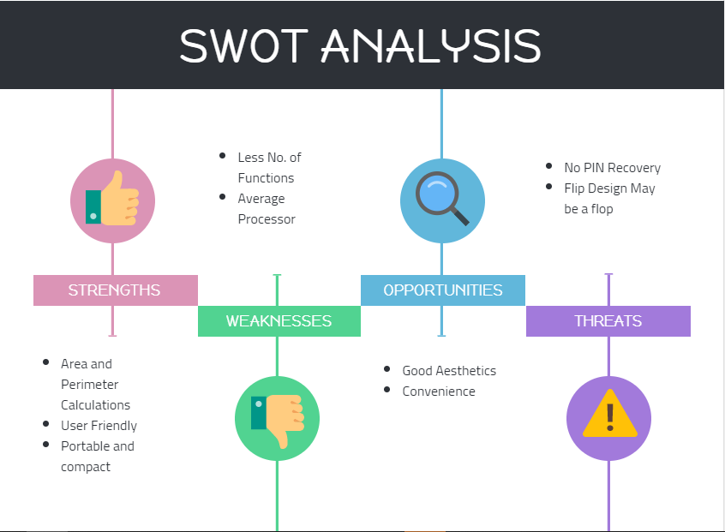
    - SWOT Analysis
Figure 1: SWOT Analysis Calculator

High Level Requirements:
ID | Description | Status | Owner
99003729 | Distance Conversions | Done | Pushkar Antony
99003730 | PIN Protection | Done | Arnav Kandpal
99003732 | Area and Perimeter Calculation | Done | Anushka Shivalli
99003728 | Arithmetic Operations | Done | Mohammed Ijaz
Table 1: High Level Requirements

Low level Requirements:
ID | Description | Status | Owner
99003729 | Metre to Inch conversion | Done | Pushkar Antony
99003729 | Metre to Feet conversion | Done | Pushkar Antony
99003730 | Writing New PIN to permanent memory into a text file | Done | Arnav Kandpal
99003730 | Reading Pin from saved file and validationg it with input pin | Done | Arnav Kandpal
99003732 | Computation of area of circle and square | Done | Anushka Shivalli
99003732 | Computation of perimeter of rectangle | Done | Anushka Shivalli
99003728 | Airthmetic Operations | Done | Mohammed Ijaz
99003728 | Modulus and Factorial Operations | Done | Mohammed Ijaz
Table 2: Low Level Requirements Calculator

Design
    - HLR Deployment diagram PIN:

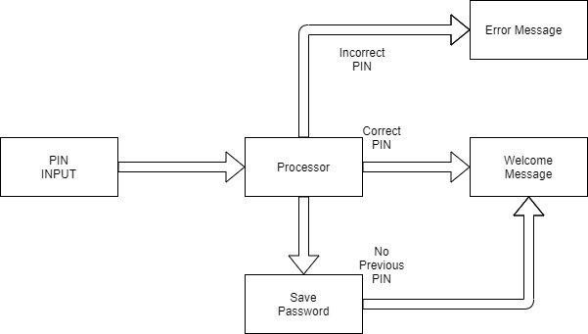
Figure 2: Deployment Diagram Calculator

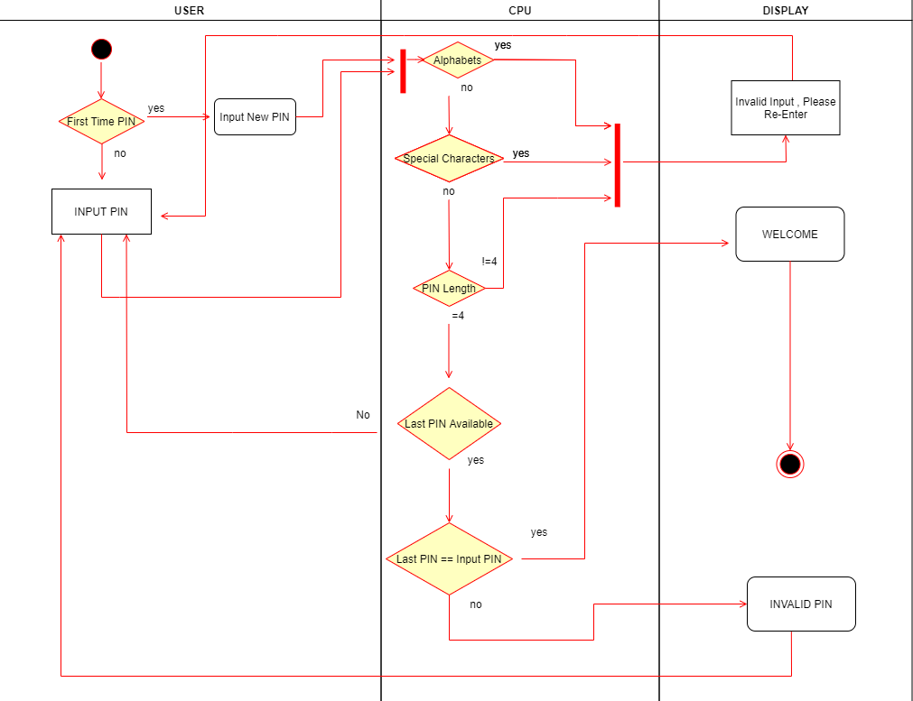
    - LLR Activity Diagram PIN:
Figure 3: Activity Diagram Calculator

Test Plan
    - High Level test plan
Test ID | Description | Exp IN | Exp OUT | Actual Out | Type Of Test
H_01 | Distance conversion- Converting unit distances from one input to the other | 10metre | 32.8 foot | 32.8 foot | Requirement based
H_02 | Password Protection for Calculator | correct pin | regular operation of calculator | Operation continued further | Scenario based
H_03 | Area and Perimeter computation | 1 | choose shape | choose shape | Requirement based
H_04 | Area and Perimeter computation | 2 | choose shape | choose shape | Requirement based
H_05 | Aritmatic operations | 2 3 | 5 | 5 | Requirement based
Table 3: High Level Test Plan Calculator

    - Low Level Test Plan:
Test ID | Description | Exp IN | Exp OUT | Actual Out | Type Of Test
L_01 | Metre to Inch Conversion | 1 metre | 39.3701 inch | 39.3701 inch | Requirement based
L_02 | Metre to Foot Conversion | 20 metre | 65.6168 foot | 65.6168 foot | Requirement based
L_03 | Writing the PIN to a local tect file so it is saved even after exiting program | PIN | PIN saved to permanent memory | PIN saved to permanent memory | scenario based based
L-04 | Checking of PIN with saved pin | correct pin | reading from text file and acceptance | acceptance of pin | scenario based
L_05 | Area computation for Circle | Radius value in cm = 1 | 3.1428 | 3.1428 | Initial boundary based
L_06 | Area computation for square | Side value in cm = 1 | 1 | 1 | Initial boundary based
L_07 | Perimeter computation for Square | Radius value in cm = 1 | 4 | 4 | Initial boundary based
L_08 | Perimeter computation for Rectangle | length value in cm = 1; width value in cm =1 | 4 | 4 | Initial boundary based
L_09 | Sum of two numbers | 2 3 | 5 | 5 | Requirement based
L_09 | difference of two numbers | 2 3 | -1 | -1 | Requirement based
L_09 | Sum of two numbers | 2 3 | 6 | 6 | Requirement based
L_09 | Sum of two numbers | 6 3 | 2 | 2 | Requirement based
Table 4 : Low Level Test Plan Calculator

Implementation Summary

Git Link
https://github.com/99003732/Team2.git

Git Dashboard

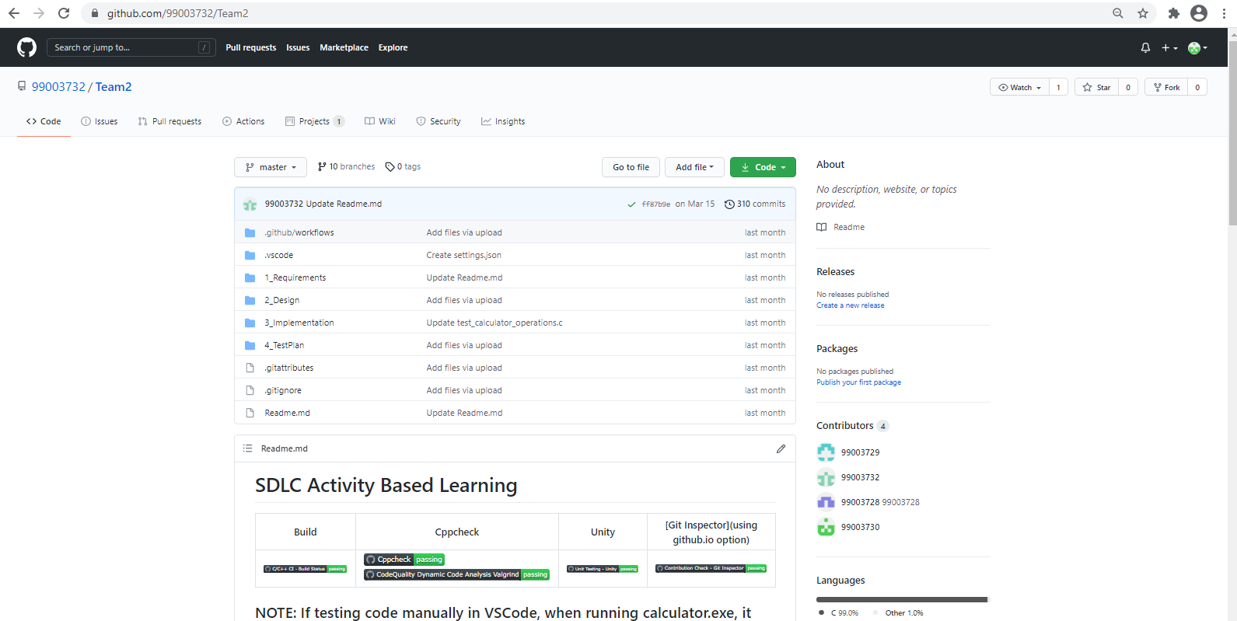
Figure 4: Dashboard Calculator

Summary
Code was developed individually and Integrated by the team using Makefile and with PIN as access function to enter all other functions.

Git inspector summary
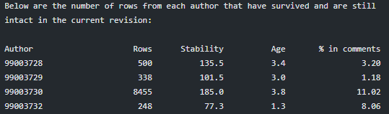
Figure 5: Git Inspector Calculator

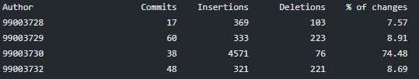
Build

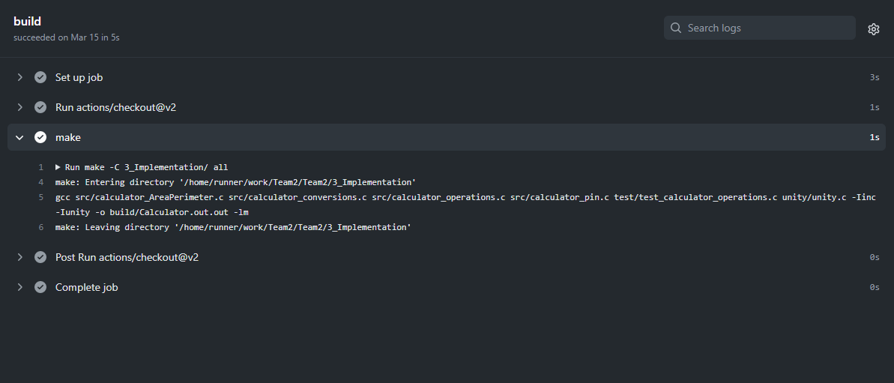
Figure 6: Build Calculator

Code quality and Issues or Bug Tracking
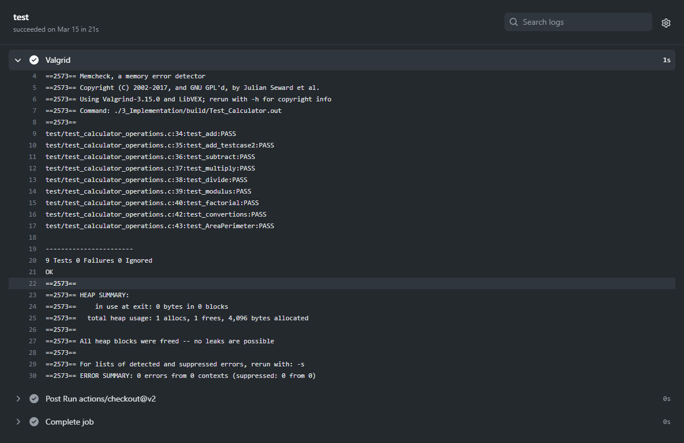
Figure 7: Code Quality Calculator

Unit Testing

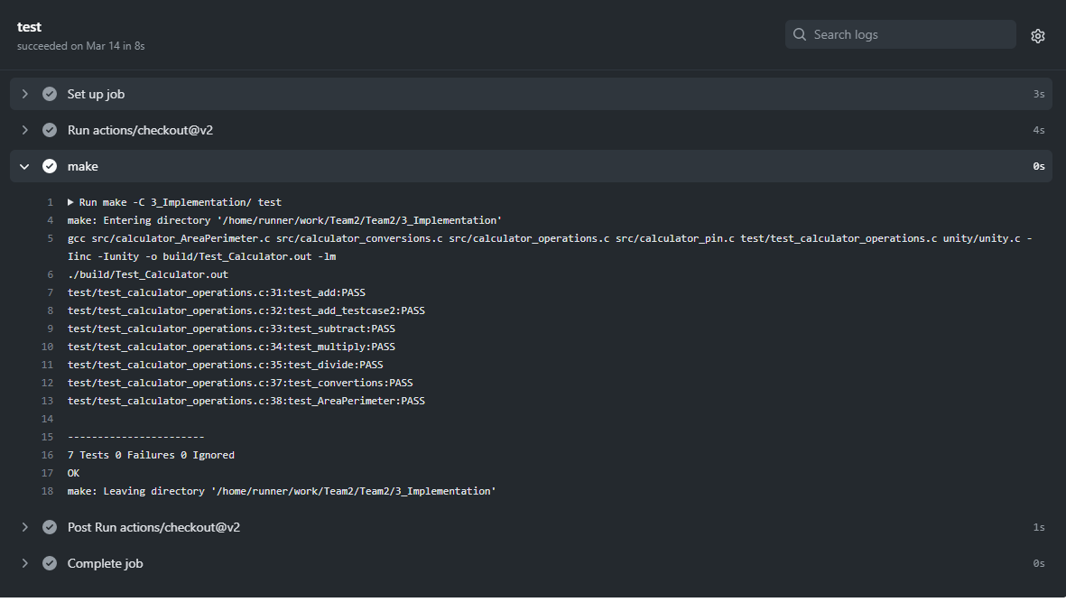
Figure 8: Unit Testing Calculator

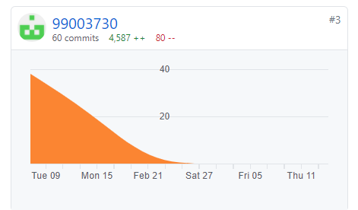
Individual Contribution & Highlights

Figure 9: Individual Contribution Calculator

Summary
The PIN feature is not implemented in any calculator yet, but colleges student has biggest worry of being stolen thus a calculator PIN feature is very useful for the student and in general other educational institutions.

Challenges faced and how were they overcome
- Issue in Making files- Solved by changing the path directory as I had made a earlier mistake while installing them.
- Making the header and .c files had some errors- Solved by trial and error methods and searching the net.
- Reading and writing to permanent memory, resolved by making a text file in local folder and saving the PIN to it.
- Valgrind check issue - Solved by running the features individually.
- Unity test issue - Solved by comparing and referring through given repository with our repository files.

Mini-Project: Word Search Automation

Module
- Advanced Python

Topics
- Regular Expression
- OOP’s Concept
- Inheritance
- Polymorphism

Objectives & Requirements
- To design a python program for searching a list of specific words provided by the user and to display the line number, and previous and next word of the given word.

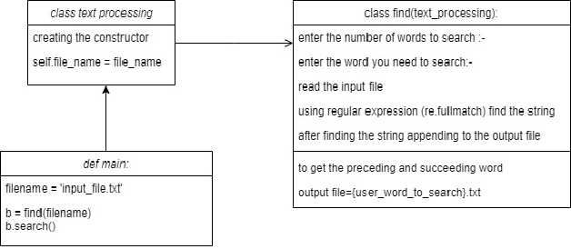
Design
Figure 10: Design Word Search

Test Plan

High Level Tests
Id | Requirements | Description | Status
HL1 | Searching Word | Search the word from the text file given by the user. | Implemented
HL2 | Writing | Write the words after and before of the searched word in new text file. | Implemented
HL3 | Extracting user defined data | Write required data in the text file. | Implemented
Table 5: High Level test Word search

Low Level Tests
Id | Requirements | Description | Status
LL1 | Search Word | The user inputs the word to be searched through the text file. | Implemented
LL2 | Searching word in every line of the text file. | The data to be searched is defined by the user and then searched throughout the entire text file. | Implemented
LL3 | Writing the data into new text file. | Data given as an input by the user is searches in every line and the word after and before is extracted too and then added in a new text file along the searched word. | Implemented
Table 6: Low level Test Word search

Implementation Summary
The Program was implemented by using regex functions and failsafe were implemented using raise Exception commands.

Git Link
https://github.com/99003730/Mini-Project-Python.git

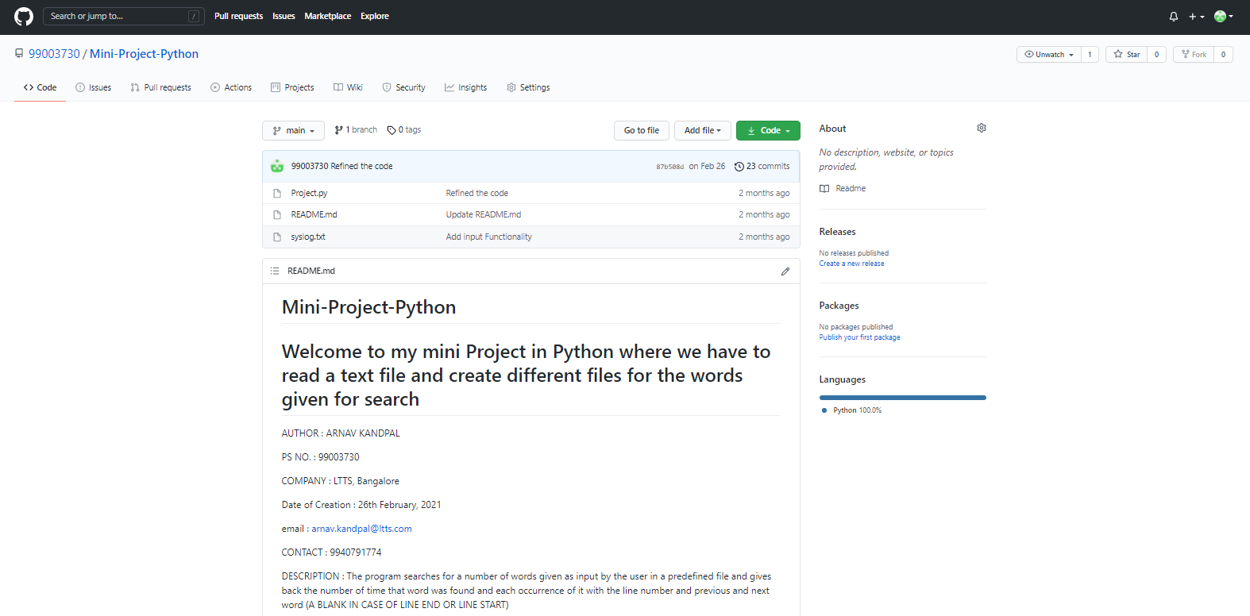
Git Dashboard
Figure 11: Dashboard Word search

Summary

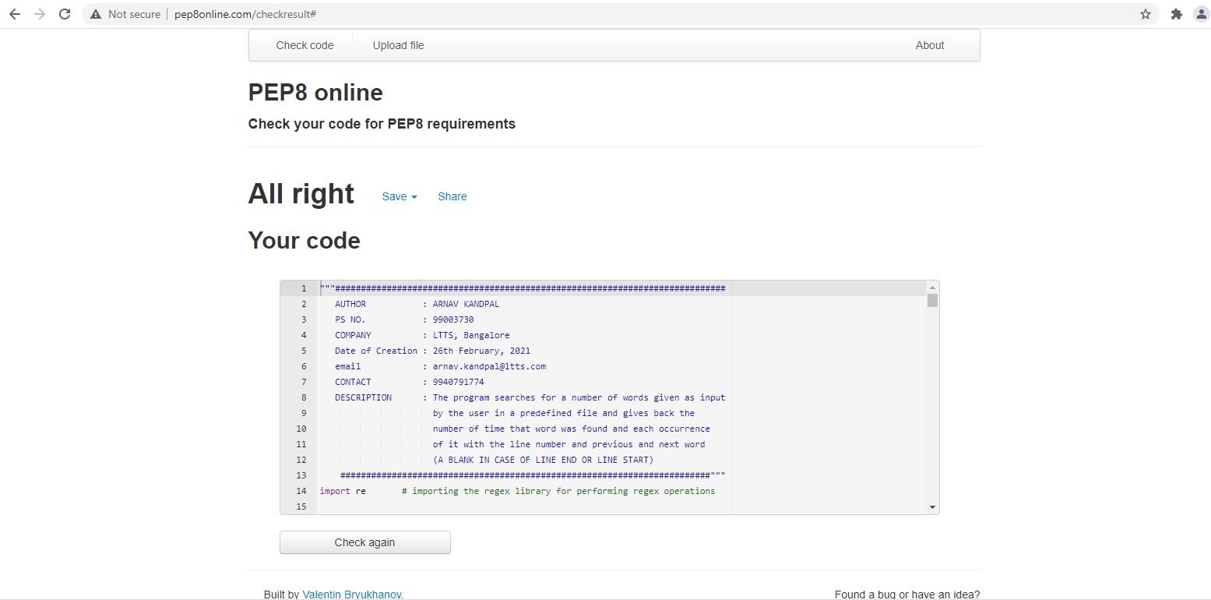
Code quality
Figure 12: Code Quality Word Search

Issues

Individual Contribution & Highlights
The Project was assigned individually thus all contribution is of one individual.

Summary
Our aim of achieving small scale automation through python was achieved.

Challenges faced and how were they overcome
- Pycharm and pep8online have different standards for number of maximum characters in a single line thus pep8online test was failing, Issue was resolved by choosing to follow pep8online standards which had the lower limit.

Mini-Project: Body Control Module

Module
- Embedded C

Topics
- Wiper Control Module.
- Exterior Lighting Module.

Objectives & Requirement
- To design Wiper control system taking reference of GMC Sierra.
- To design External lighting system taking reference of GMC Sierra.

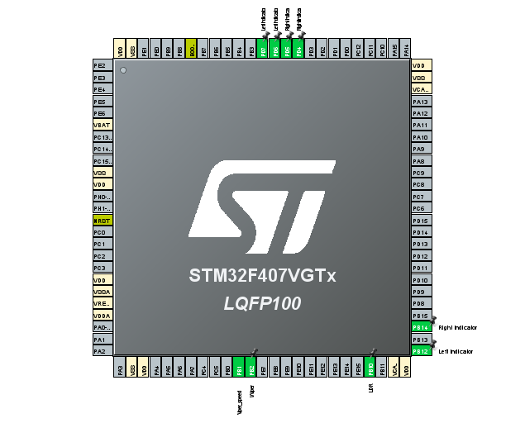
Design
Figure 13: Design BCM

Test Plan

High Level Tests
Id | Requirements | Description | Status
HL1 | Wiper Control | Wiper Should be controlled by Resistive Pot | Implemented
HL2 | Exterior Lighting | Headlights & Indicators should be implemented using push button | Implemented
Table 7:High Level Test BCM

Low Level Tests
Id | Requirements | Description | Status
LL1 | Wiper Control | Wiper speed should increase with decreased resistance of pot | Implemented
LL2 | Wiper Control | Wiper speed should decrease with decreased resistance of pot | Implemented
LL3 | Exterior Lighting | Headlights should turn on automatically in dark environment | Implemented
LL4 | Exterior Lighting | Left and right indicators should toggle on off every 100ms after pressing the button | Implemented
Table 8: Low Level Test BCM

Implementation Summary
The program was implemented using STM32 IDE and board, along with other hardware components like resistive pot, LED’s, LDR, breadboard, push buttons.
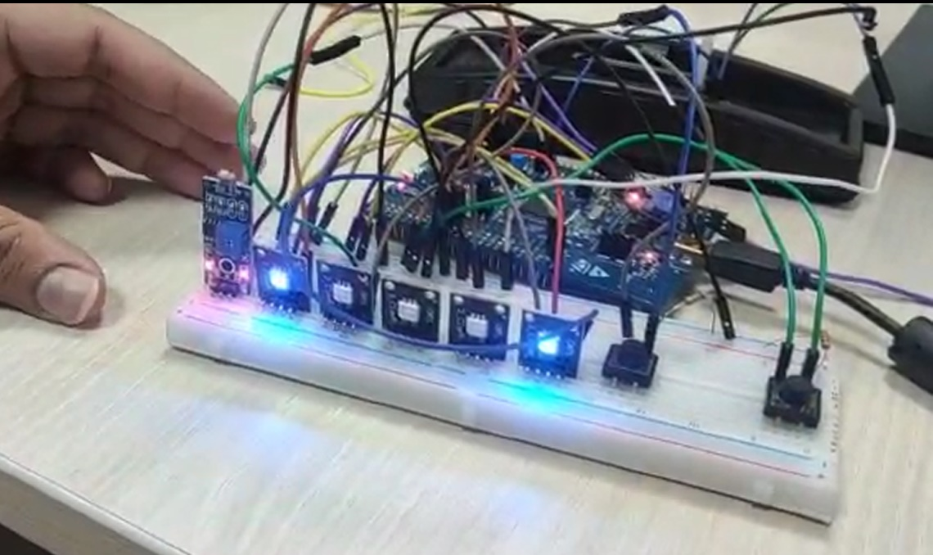
Figure 14: Implementation BCM

Video Summary

Link:
https://lnttsgroup.sharepoint.com/:v:/r/sites/GEA/Global%20Engineering%20Academy/GENESIS%20%20Jan%202020%20Submission/Submission/BANGALORE/2002BLRGT04/99003730/Embedded_C/99003730,99003745%20embedded%20c.mp4?csf=1&web=1&e=AMJ8vQ

Git Link

https://github.com/99003730/Mini_Project_EmbeddedC.git

Git Dashboard
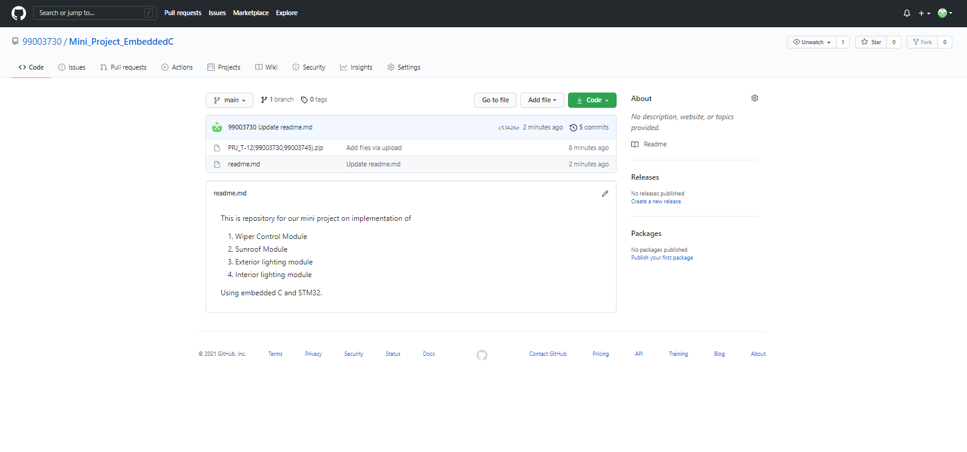
Figure 15: Git Dashboard BCM

Individual Contribution & Highlights

Summary
- Wiper Control module was implemented using resistive pot for different speeds,
- Automatic Headlamps were implemented using LDR sensor.

Challenges faced and how were they overcome
- Push button was not working because no drain resistor was connected to the button thus the voltage was floating, resolved by connecting a resistor of 220 through push button to ground.

Mini-Project: Body Control Module

Module
- Model Based System Engineering

Topics

Power windows: Power window have a structure much like the hand powered or manual windows. The difference is the handle bars are replaced with motor and the motion is now actuated with the actuator or power circuit thus the name “Power Window”.

Objectives & Requirements
- To design a power window module with anti-pinch mechanism.

High Level requirements
- Power Window feature should be implemented.
- Driver should get more priority than the passenger.
- A disable passenger window switch should be present.
- Anti-Pinch feature should be implemented.

Low Level Requirements
- The window should go up upon pulling up the Rocker switch to a maximum position of 5.
- The window should go down when pushing down the rocker switch to a minimum position.
- The window should come to halt at any stage of operation by releasing the toggle switch.
- When the driver pulls up the switch and passenger push down the switch at same time the window should go up.
- When the driver pushes down the switch and passenger pull up the switch at same time the window should go down.
- When the switch is pushed down to a position of -2 the window should enter the operation express down.
- The Express up should be cancelled by the user pushing down the switch.
- The Express down should be cancelled by user by pulling up the switch.
- When the switch is pulled up to a position of 2 the window should enter the operation Express up.
- When disable passenger window switch is enabled none of the passenger input be considered.
- An obstruction should be detected when motor draw crosses the threshold set as
- On Detection of an obstruction the Anti-Pinch System should move the window pane to a position of 0.
- When Anti-Pinch function is in action any command given by the driver should be neglected until the window pane reaches the reset position of 0.
- When Anti-Pinch function is in action any command given by the passenger should be neglected until the window pane reaches the reset position of 0.

Design
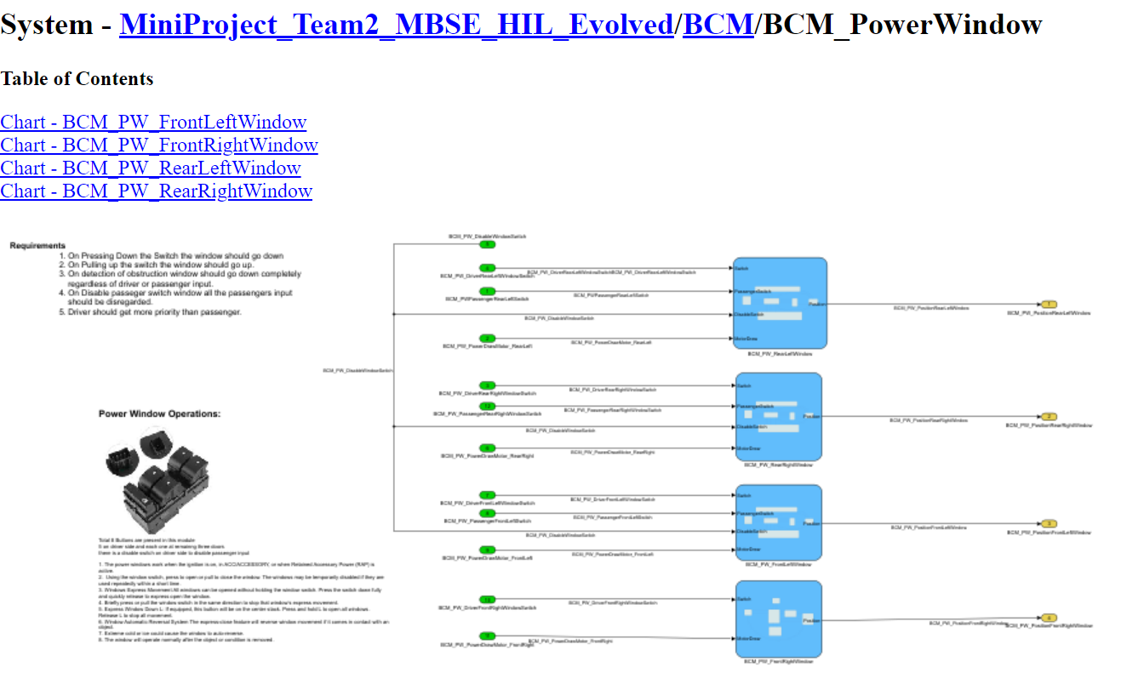
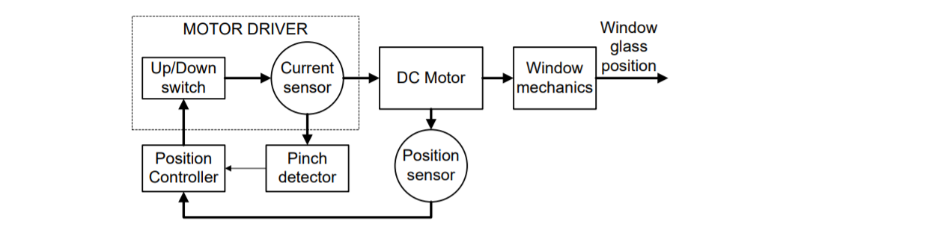
Figure 16: Design Power Window
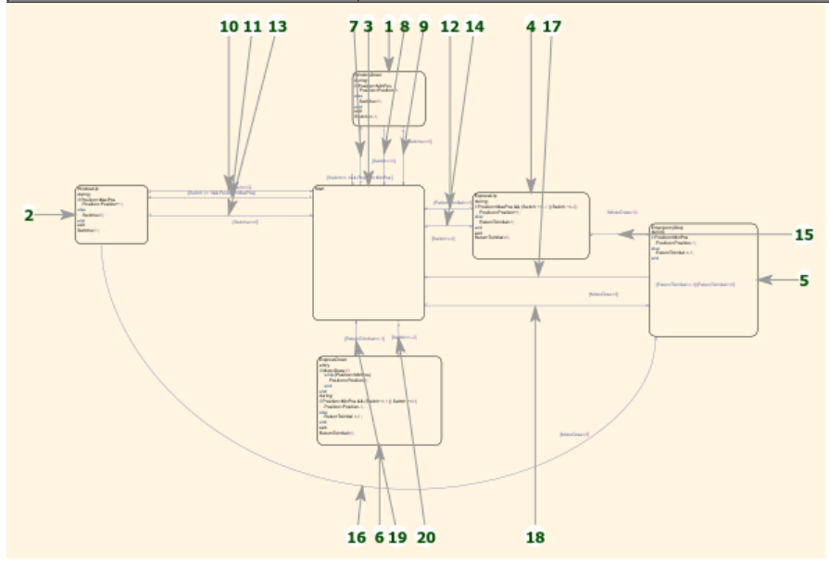
Figure 17: Stateflow Power Window
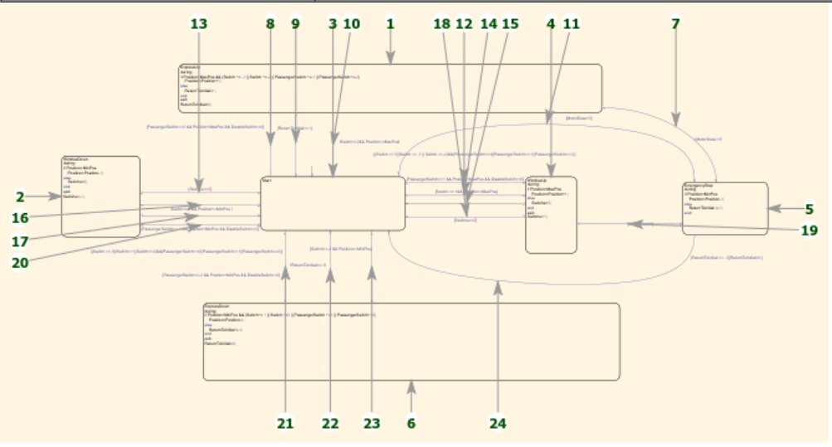
Figure 18: Stateflow Power Window 2

Test Plan
Test ID | Description | Exp IN | Exp OUT | Actual Out | Type Of Test | TimeStamp
HLR_PW_01 | Does Window go up on pulling up the rocker switch | 1 | Increase in window position from 0-5 | Position Increased | Requirement based | 0-5 sec
HLR_PW_02 | Does Window go down on pushing down the rocker switch | -1 | Decrease in window position from 5-0 | Position Decreased | Requirement based | 0-5 sec
HLR_PW_03 | Does disable passenger window switch stops window operation from passenger side. | Disable=1 | No position Change | No position Change | Requirement based | 0-5
HLR_PW_04 | The window should roll back on detection of pinch | Motor  draw=4 | Window roll back | Window rolled back | Requirement based | 0-4sec

High Level Tests
Table 9: High level test Power Window

Low Level Tests
Test ID | Description | Expected INPUT | Expected OUTPUT | Actual OUTPUT | Type Of Test | Time Stamp
LLR_PW_01 | Driver wants to pull up and passenger wants to pull down the same window | Driver=1  Passenger=-1 | Increase in window position from 0-5 | Position Increased | Boundary Condition | 0-5sec
LLR_PW_02 | Driver wants to pull down and passenger wants to pull up the same window | Driver=-1  Passenger=1 | Decrease in window position from 5-0 | Position Increased | Boundary Condition | 0-5 sec
LLR_PW_03 | The window should come to halt at any stage of operation by releasing the toggle switch | 1 | Increase in window position from 1-3 | Halted at 3 | Requirement based | 0-3sec
LLR_PW_04 | When the switch is pushed down to a position of -2 the window should enter the operation express down. | -2 | Window move to position 0 | Window move to position 0 | Requirement based | 0-5sec
LLR_PW_05 | When the switch is pulled up to a position of 2 the window should enter the operation express up. | 2 | Window move to a position of 5 | Window move to a position of 5 | Requirement based | 0-5sec
LLR_PW_06 | On Detection of an obstruction the Anti-Pinch System should move the windowpane to a position of 0. | 4 | Window move to position 0 | Window move to position 0 | Requirement Based | 0-5sec
LLR_PW_07 | When Anti-Pinch function is in action any command given by the driver should be neglected until the window pane reaches the reset position of 0. | Motor Draw = 4  Driver Input = 2 | Window pane move to 0 | Window pane move to 0 | Requirement Based | 0-5sec
LLR_PW_07 | When Anti-Pinch function is in action any command given by the passenger should be neglected until the window pane reaches the reset position of 0. | Motor Draw = 4  Driver Input = 1 | Window pane move to 0 | Window pane move to 0 | Requirement Based | 0-5sec
Table 10: Low Level Tests Power Window

Implementation Summary

Video Summary
Link: : https://lnttsgroup.sharepoint.com/:v:/r/sites/GEA/Global%20Engineering%20Academy/GENESIS%20%20Jan%202020%20Submission/Submission/BANGALORE/2002BLRGT04/Project/Team-2/Evolved_MBSE_MiniProject/7_Video/Team2_MiniProject%20(1).mp4?csf=1&web=1&e=hIDgxL

SharePoint Link
Link: https://lnttsgroup.sharepoint.com/:f:/r/sites/GEA/Global%20Engineering%20Academy/GENESIS%20%20Jan%202020%20Submission/Submission/BANGALORE/2002BLRGT04/Project/Team-2/Evolved_MBSE_MiniProject?csf=1&web=1&e=5XCuJs

SharePoint Dashboard

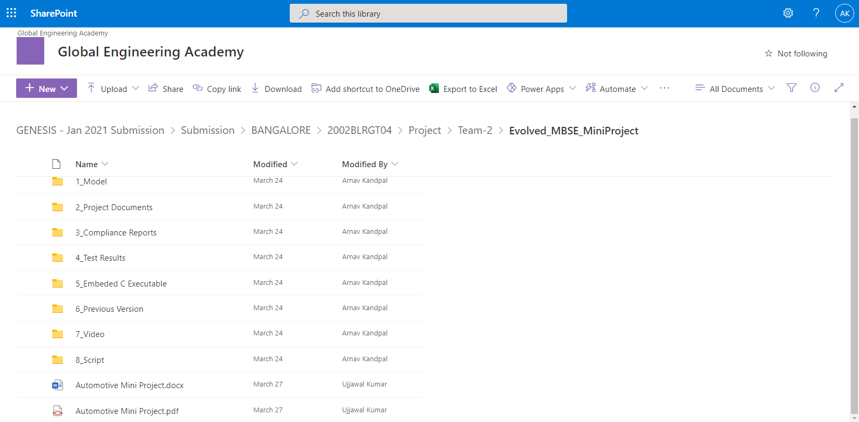
Figure 19: Dashboard Power Window

Summary

Code quality and Issues or Bug Tracking
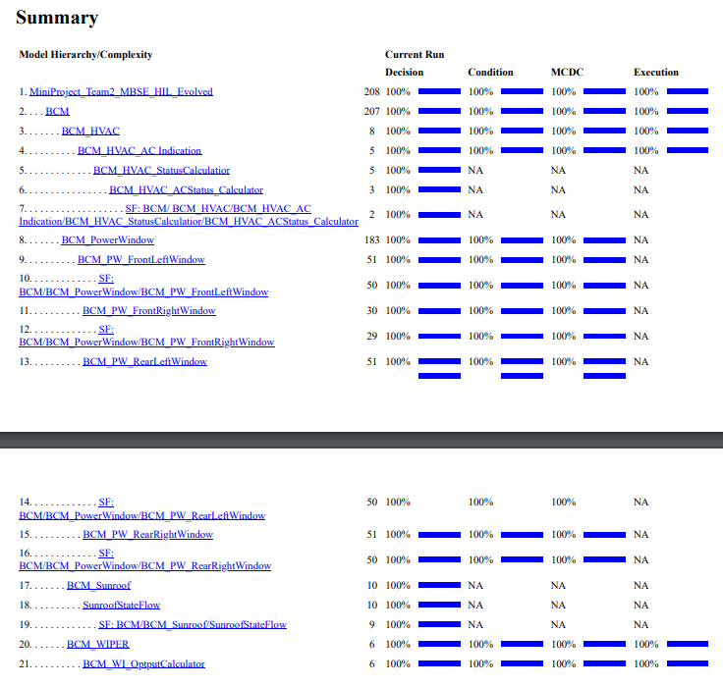
MCDC Report:
Figure 20:MCDC Power Window

Individual Contribution & Highlights
- Power Window Implementation.

Summary

Challenges faced and how were they overcome
Making Model 100% MCDC compliant, by labeling every line and changing some logic in the model.

Canoe and CAPL Scripting (Launch Control)

Module
- Canoe
- CAPL

Topic and Subtopics
- RPM
- Gear Shift
- Turbo Boost
- Speedometer
- Launch Control

Objectives & Requirements
To implement launch control of McLaren 745LT,using Canoe and CAPL scripting.

Design

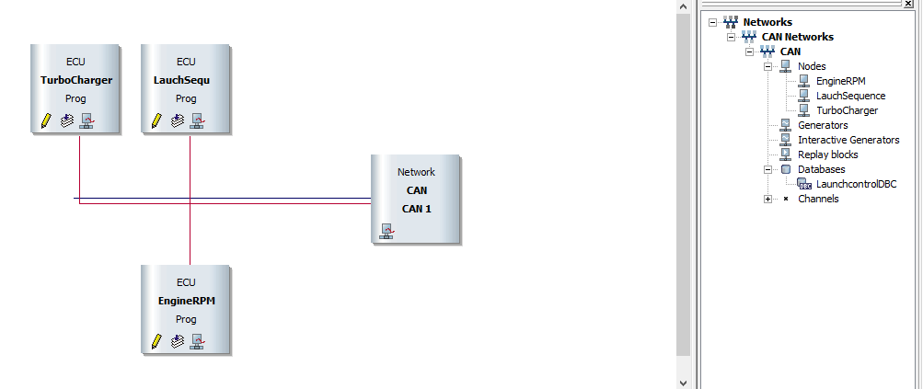
Figure 21: Design Launch Control

Test Plan

Test ID | Description | Exp IN | Exp OUT | Actual Out | Type Of Test
LC_1 | Lunch Control | 1.Apply brake  2.Turn On Active Mode  3.Turn On Launch Control  4.Apply full Accelerator  5. Release Brake | Launch Control Activated | Lunch Control Activated | Requirement Based
LC_2 | Lunch Control | 1.Apply brake  2.Active Mode OFF  3.Apply full Accelerator  4. Release Brake | Launch Control cannot be Activated | Launch control is not Activated | Scenario Based
LC_3 | Launch Control | 1.Turn On Active Mode  2.Turn On Launch Control  3.Apply full Accelerator | Launch Control cannot be Activated | Launch control is not Activated | Scenario Based
NM_01 | Normal Mode  Drive | Apply Accelerator for speeding up | Vehicle Speed increase | Vehicle Speed is increasing | Requirement Based
NM_02 | Stopping | Apply Brake pedal | Vehicle speed decreases | Vehicle Speed is decreasing | Requirement Based
Table 11: Test Plan Launch Control

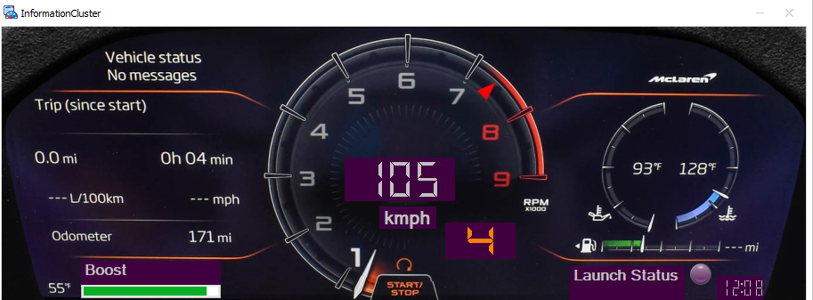
Implementation Summary
Figure 22: Control Panel Launch Control
Figure 23: Cluster Launch Control
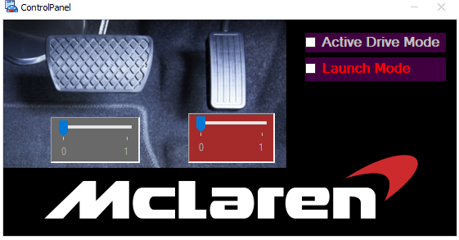

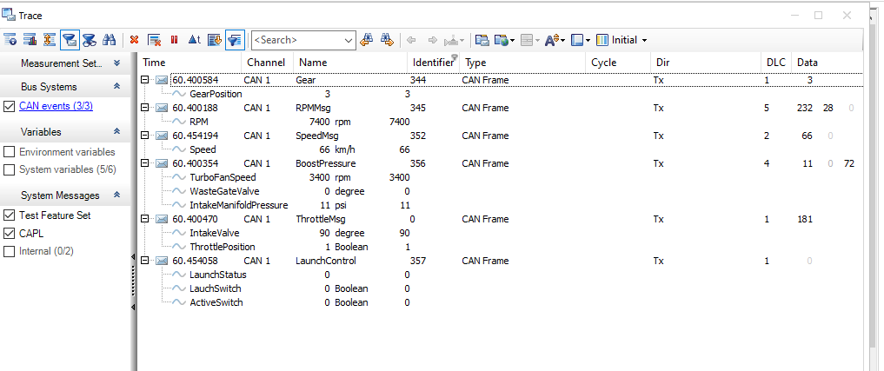
Figure 24:Trace Launch Control

SharePoint Link
Link: https://lnttsgroup.sharepoint.com/:f:/r/sites/GEA/Global%20Engineering%20Academy/GENESIS%20%20Jan%202020%20Submission/Submission/BANGALORE/2002BLRGT04/99003745/CANOE?csf=1&web=1&e=UOVlUi

SharePoint Dashboard
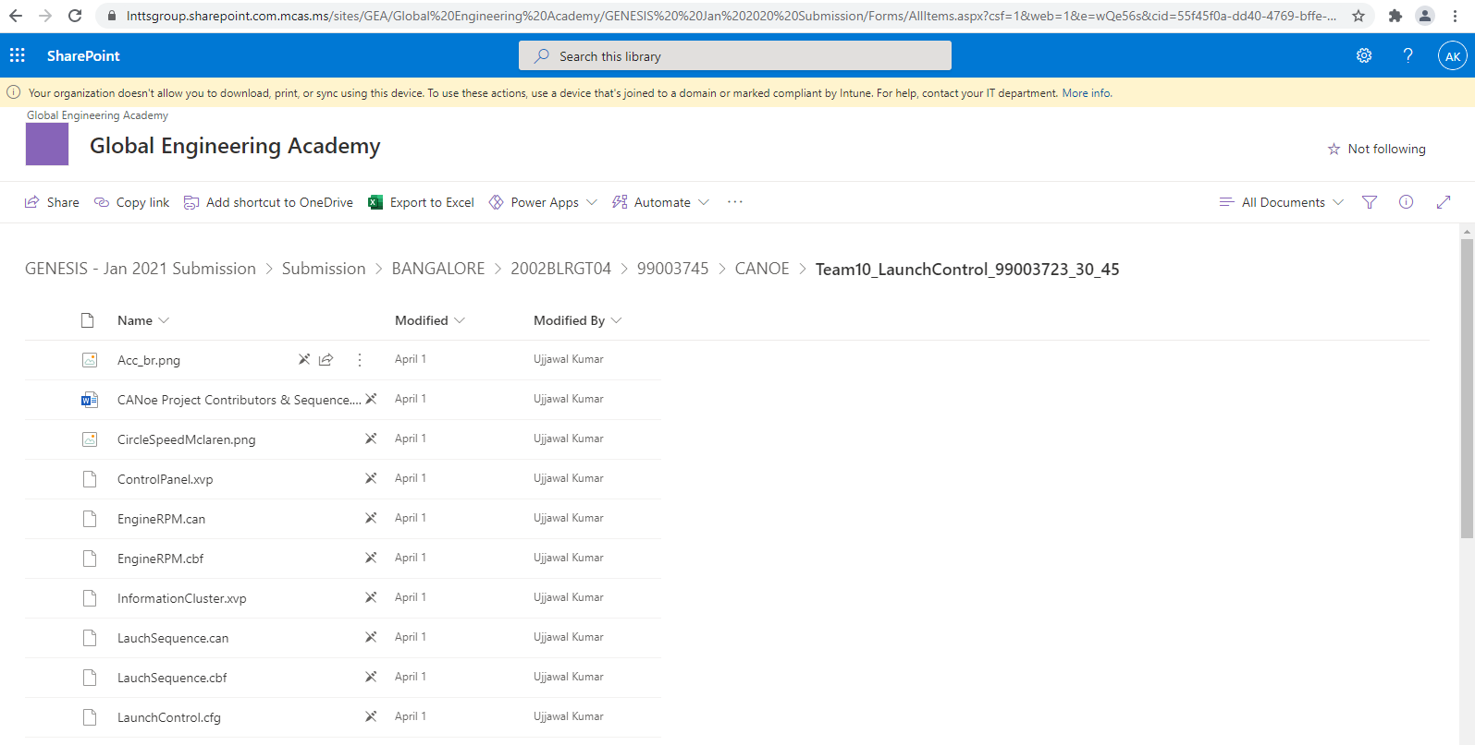
Figure 25:Dashboard Launch Control

Individual Contribution & Highlights
- Gear Shifting
- Turbo Pressure management

Summary
To manage turbo pressure a waste gate valve Is used with is depended on the turbo fan speed and pressure.

Challenges faced and how were they overcome
Integrating every component into one system, overcame by changing parts of code.

Intermediate C++ (Calculator)

Module
- Intermediate C++

Topic and Subtopics
- Operator Overloading
- Classes and Objects
- Constructor overloading

Objectives & Requirements
To design a Calculator that can add, subtract multiply, divide , integers, floating numbers, fractions, complex numbers .

Test Plan
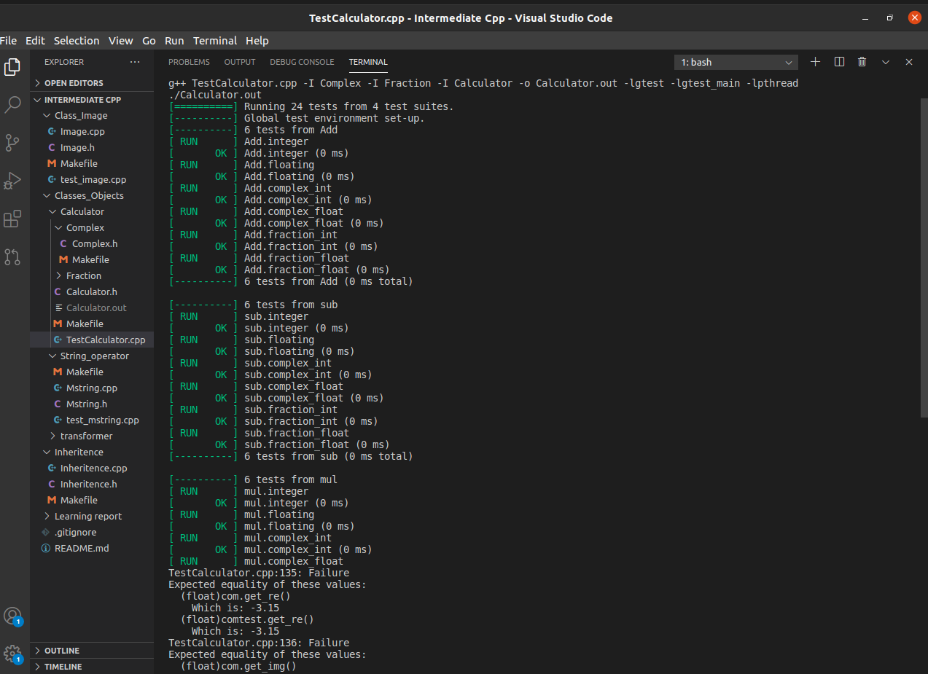
Figure 26: Test Plan C++

Implementation Summary

Git Link
https://Demobrt@dev.azure.com/Demobrt/Intermediate%20Cpp/_git/Intermediate%20Cpp

Git Dashboard
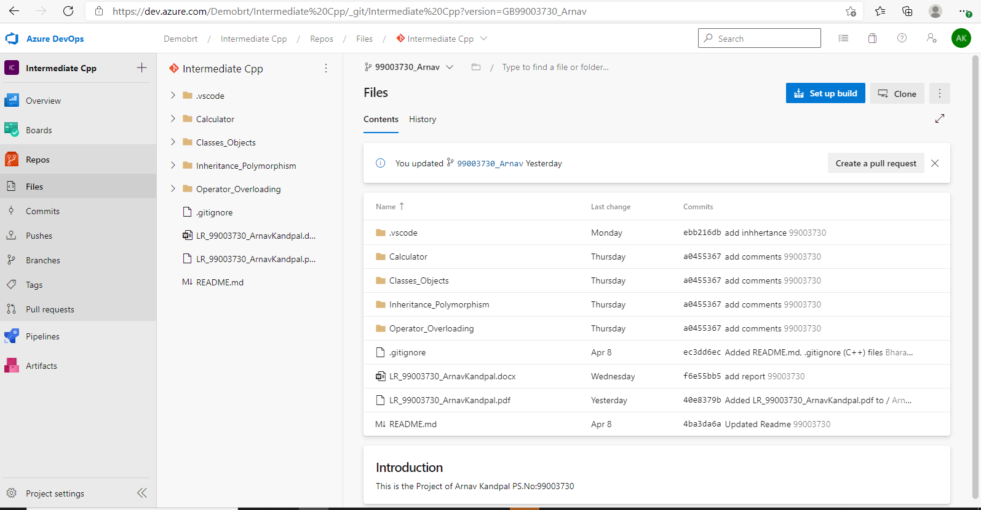
Figure 27: Dashboard C++

Summary
The code was implemented making separate libraries of fraction and complex numbers and then integrating them with our main code.

Individual Contribution & Highlights
The Project was assigned individually thus all contribution is of one individual.

Challenges faced and how were they overcome
Including all the function in a single library, resolved by making multiple libraries.

